**GTA Landscaping: User View 1**

Unf:

Invoice [ **PK cust_info**, cust_addr, (Inv_num, Inv_date, work_team, Eq_used, serv_code, serv_desc, hr_chrg, durate, total_chrg, subtotal)]

1nf:

Invoice [ **PK cust_info**, cust_addr]

Invoice_Details [ **PK Inv_num**, Inv_date, work_team, Eq_used, serv_code, serv_desc, hr_chrg, durate, total_chrg, subtotal, fk cust_info]

2nf:

Invoice [ **PK cust_info**, cust_addr, FK Inv_num]

Invoice_Details [ **PK Inv_num**, Inv_date , FK work_team]

Team_Desc [ **PK work_team,** Eq_used, FK serv_code]

Service [ **PK serv_code,** serv_desc, hr_chrg, durate, total_chrg, subtotal]

3nf:

Invoice [ **PK cust_info**, cust_addr, FK Inv_num]

Invoice_Details [ **PK Inv_num**, Inv_date , FK work_team]

Team_Desc [ **PK work_team,** Eq_used, FK serv_code]

Service [ **PK serv_code,** serv_desc]

Unit_Price [ **FK PK serv_code,** hr_chrg]

Charge_Service [ **CK FK hr_chrg, CK durate,** total_chrg]

Subtotal [ **PK FK total_chrg,** subtotal]

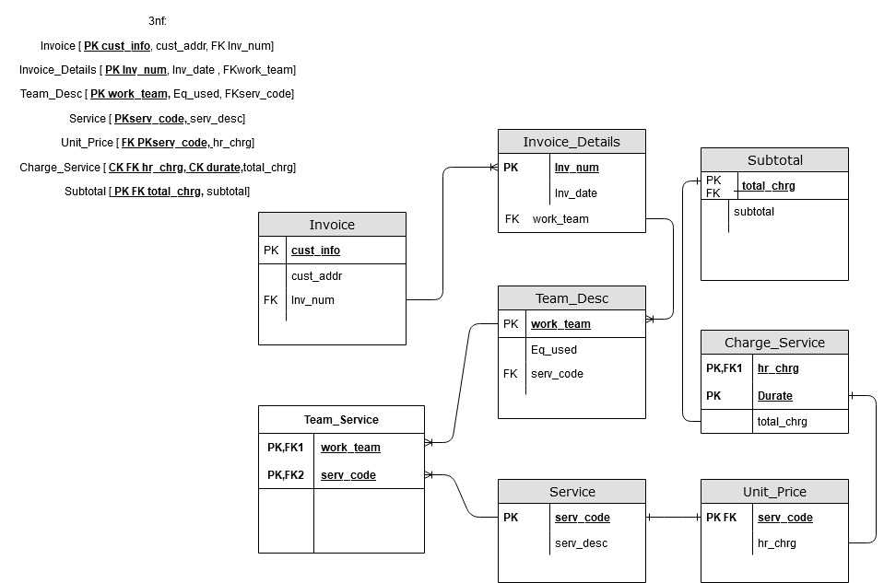

#### GTA Landscaping: User View 2

Unf:

Team [ **PK team_id,** team_desc,( emp_id, emp_name, emp_ohip, emp_tel, emp_start_dt, emp_skill)]

1nf:

Team [ **PK team_id,** team_desc, fk emp_id]

Employee [ **PK emp_id**, emp_name, emp_ohip, emp_tel, emp_start_dt, emp_skill]

2nf:

Team [ **PK team_id,** team_desc, fk emp_id]

Employee [ **PK emp_id**, emp_name, emp_tel, emp_start_dt, emp_skill]

Emp_Ohip [**CK FK emp_id, CK emp_ohip**]

3nf:

Team [ **PK team_id,** team_desc, fk emp_id]

Employee [ **PK emp_id**, emp_name]

Telephones [ **PK FK emp_id,** emp_tel]

Start_Date [ **PK FK emp_id,** emp_start_dt]

Skills [ **PK FK emp_id,** emp_skill]

Emp_Ohip [**CK FK emp_id, CK emp_ohip**]

